AIRLINE INDUSTRY DATA ANALYSIS
Factors Influencing Coach Ticket Prices

Field | Detail
Course | STAT-2205 — Programming with R and Python
Name | Jannatul Mawa Joty
Student ID | 12310053
Dataset | flight_data.csv (129,780 observations)
Sample Size | 10,000 rows (random_state / seed = 10053)
Language | Python & R
Objective | Reveal factors influencing coach ticket prices

Submitted to: Dr. Md. Siddikur Rahman
Academic Year 2023–2024

#wd Setup
getwd()
setwd("E:/2nd. 2nd Semester/STAT-2205 R programming")
getwd()
list.files()
airline_random_1000 <- read.csv("flight_data_csv.csv")
head(airline_random_1000)
View(airline_random_1000)
str(airline_random_1000)
View(airline_random_1000)

#My_ID_Sum+New_variable
my_id <- 10053
airline_random_1000$new_miles <- airline_random_1000$miles + my_id
airline_random_1000$new_passengers <- airline_random_1000$passengers + my_id
airline_random_1000$new_coach_price <- airline_random_1000$coach_price + my_id
airline_random_1000$new_firstclass_price <- airline_random_1000$firstclass_price + my_id
View(airline_random_1000)

#Q1 Solution :
max(airline_random_1000$new_coach_price) #highest price
min(airline_random_1000$new_coach_price) #lowest price
median(airline_random_1000$new_coach_price) #median
sd(airline_random_1000$new_coach_price) #distribution
hist(airline_random_1000$new_coach_price,
main = "Histogram of Coach Ticket Price",
xlab = "Coach Ticket Price",
ylab = "Frequency",
col = "skyblue",
border = "black")
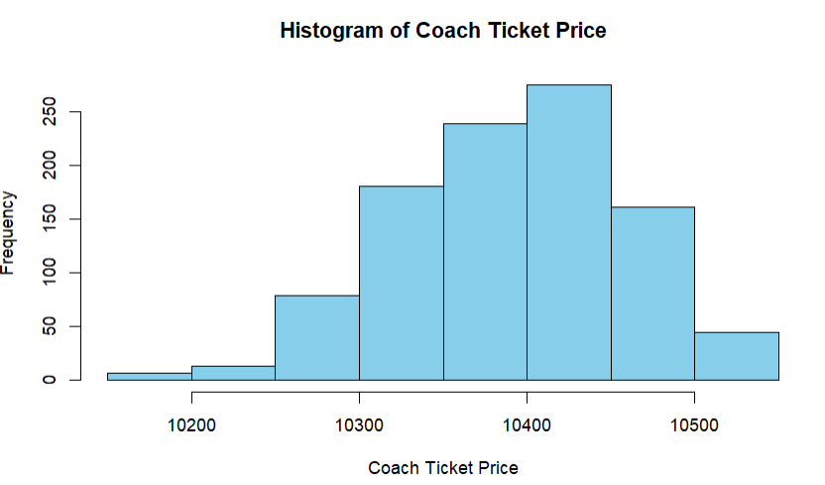
boxplot(airline_random_1000$new_coach_price,
main = "Boxplot of Coach Ticket Price",
ylab = "Coach Ticket Price",
col = "red",
border = "black")
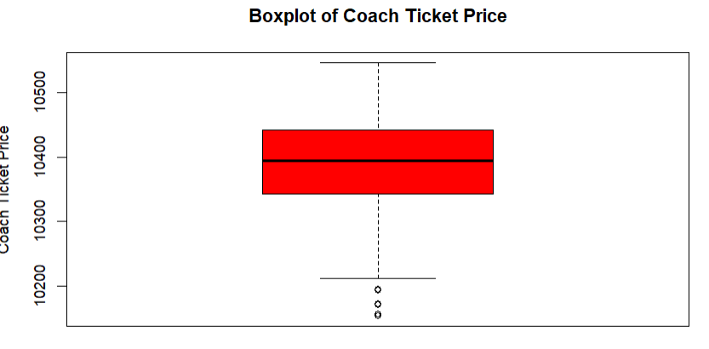

#Q2: 8-Hour Flight Analysis
flight_8_hr <- subset(airline_random_1000, hours == 8)
summary(flight_8_hr$new_coach_price)
mean(flight_8_hr$new_coach_price)
min(flight_8_hr$new_coach_price)
max(flight_8_hr$new_coach_price)

#Q3: Flight Delay Distribution
summary(airline_random_1000$delay)
hist(airline_random_1000$delay,
main = "Flight Delay Distribution",
xlab = "Delay Minutes",
ylab = "Frequency",
col = "orange",
border = "black")
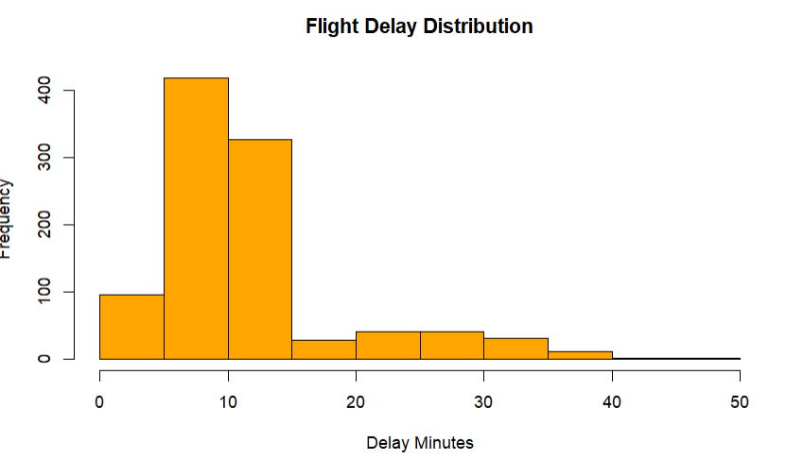
boxplot(airline_random_1000$delay,
main = "Delay Boxplot",
ylab = "Delay Minutes",
col = "yellow")
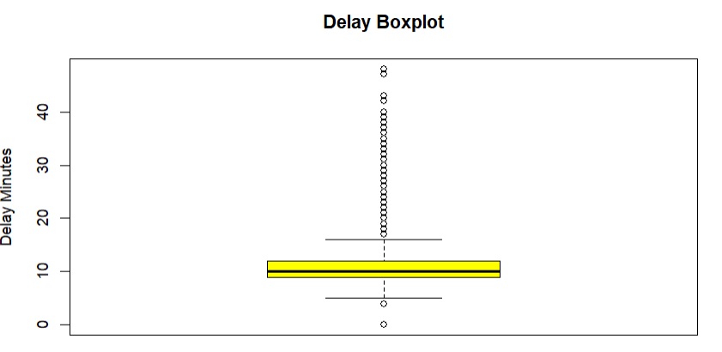
#Interpretation
#Most flights delay 0–20 minutes
# Some flights delay over 100 minutes

#Q4: Correlation with Coach Price
cor(airline_random_1000$coach_price, airline_random_1000$new_miles)
cor(airline_random_1000$coach_price, airline_random_1000$new_passengers)
cor(airline_random_1000$coach_price, airline_random_1000$delay)
cor(airline_random_1000$coach_price, airline_random_1000$hours)
plot(airline_random_1000$new_miles,
airline_random_1000$new_coach_price,
main = "New Miles vs New Coach Price",
xlab = "Miles",
ylab = "Coach Price",
col = "blue")
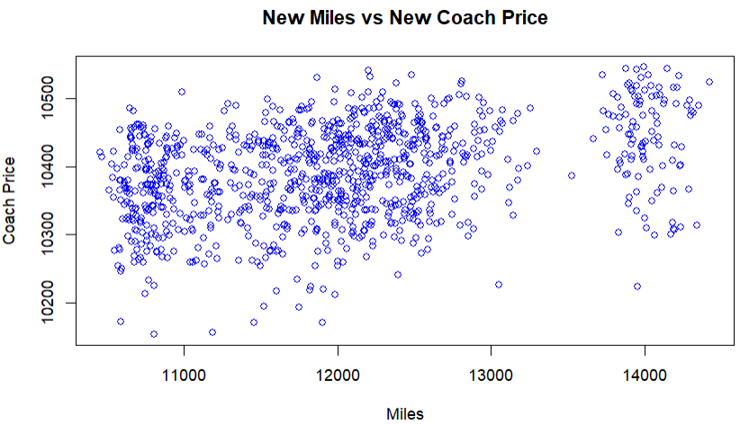
#Interpretation
#Longer distance flights cost more
# Hours have positive correlation with price
# Delay has weak relation

#Q5: Coach vs First-Class Price
cor(airline_random_1000$new_coach_price,
airline_random_1000$new_firstclass_price)
plot(airline_random_1000$new_coach_price,
airline_random_1000$new_firstclass_price,
main = "Coach vs First Class Price",
xlab = "Coach Price",
ylab = "First Class Price",
col = "darkgreen")
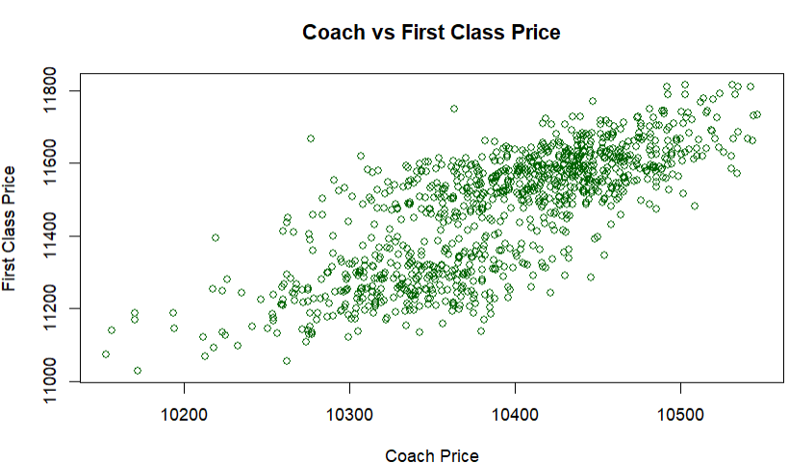
#Interpretation
#Strong positive correlation exists
# Higher coach prices usually mean higher first-class prices

#Question 6: WiFi / Meal / Entertainment Effect
aggregate(new_coach_price ~ inflight_wifi,
data = airline_random_1000,
mean)
aggregate(new_coach_price ~ inflight_meal,
data = airline_random_1000,
mean)
aggregate(new_coach_price ~ inflight_entertainment,
data = airline_random_1000,
mean)
#Interpretation
#Flights with WiFi have higher average prices
# Entertainment and meals also increase prices

#Question 7: Passengers vs Flight Hours
cor(airline_random_1000$passengers,
airline_random_1000$hours)
plot(airline_random_1000$hours,
airline_random_1000$passengers,
main = "Hours vs Passengers",
xlab = "Flight Hours",
ylab = "Passengers",
col = "purple")
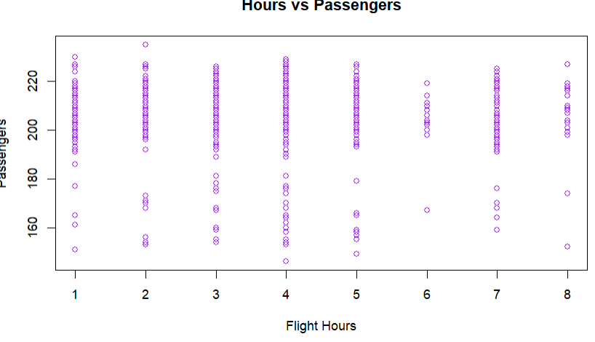
#Interpretation Weak positive relation exists
# Longer flights tend to carry slightly more passengers

#Question 8: Weekend vs Weekday Price
aggregate(new_coach_price ~ weekend,
data = airline_random_1000,
mean)
boxplot(new_coach_price ~ weekend,
data = airline_random_1000,
main = "Weekend vs Weekday Prices",
col = "cyan")
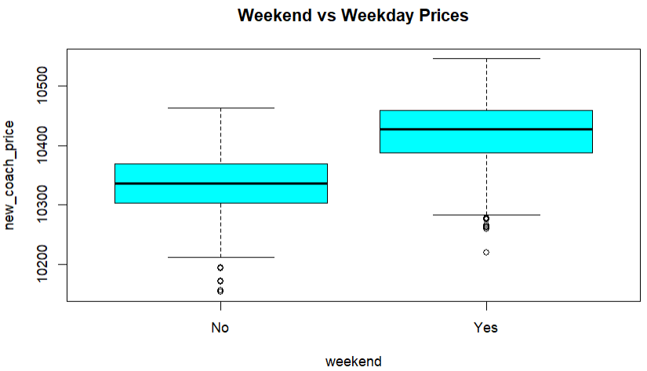
t.test(new_coach_price ~ weekend,
data = airline_random_1000)
# Interpretation
# Weekend flights are slightly more expensive
# If p-value < 0.05 → significant difference

#Question 9:Redeye vs Non-Redeye
aggregate(new_coach_price ~ redeye,
data = airline_random_1000,
mean)
boxplot(new_coach_price ~ redeye,
data = airline_random_1000,
main = "Redeye vs Non-Redeye",
col = "pink")
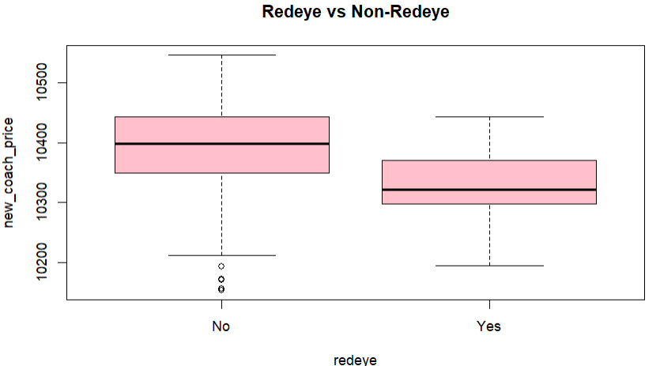
# Interpretation
# Redeye flights are cheaper
# Overnight travel is less preferred

# Question 10: Full Statistical Analysis
summary(airline_random_1000)
mean(airline_random_1000$new_coach_price)
median(airline_random_1000$new_coach_price)
sd(airline_random_1000$new_coach_price)
cor(airline_random_1000[,c("coach_price",
"miles",
"delay",
"hours",
"passengers")])
#Linear Regression
model <- lm(coach_price ~ hours +
miles +
delay,
data = airline_random_1000)
summary(model)
# Interpretation
#Miles significantly increase coach price
#Hours also increase price
#Delay has smaller effect

